From Center for the Enhancement of Teaching and Learning. http://ar.cetl.hku.hk/images/blooms.gif

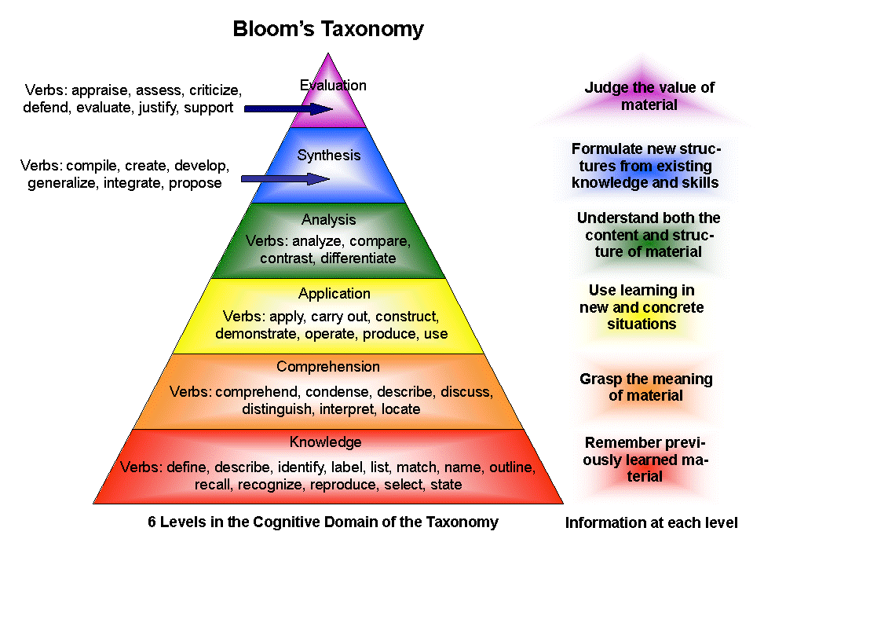
Definitions | Knowledge | Comprehension | Application | Analysis | Synthesis | Evaluation
Bloom’s  Definition | Remember  previously  learned  information. | Demonstrate an  understanding of  the facts. | Apply knowledge  to actual  situations. | Break down  objects or ideas  into simpler parts  and find evidence  to support  generalizations. | Compile  component  ideas into a new  whole or  propose  alternative  solutions. | Make and defend  judgments based  on internal  evidence or  external criteria.
Verbs | • Arrange  • Define  • Describe  • Duplicate  • Identify  • Label  • List  • Match  • Memorize  • Name  • Order  • Outline  • Recognize  • Relate  • Recall  • Repeat  • Reproduce  • Select  • State | • Classify  • Convert  • Defend  • Describe  • Discuss  • Distinguish  • Estimate  • Explain  • Express  • Extend  • Generalized  • Give example(s)  • Identify  • Indicate  • Infer  • Locate  • Paraphrase  • Predict  • Recognize  • Rewrite  • Review  • Select  • Summarize  • Translate | • Apply  • Change  • Choose  • Compute  • Demonstrate  • Discover  • Dramatize  • Employ  • Illustrate  • Interpret  • Manipulate  • Modify  • Operate  • Practice  • Predict  • Prepare  • Produce  • Relate  • Schedule  • Show  • Sketch  • Solve  • Use  • Write | • Analyze  • Appraise  • Breakdown  • Calculate  • Categorize  • Compare  • Contrast  • Criticize  • Diagram  • Differentiate  • Discriminate  • Distinguish  • Examine  • Experiment  • Identify  • Illustrate  • Infer  • Model  • Outline  • Point out  • Question  • Relate  • Select  • Separate  • Subdivide  • Test | • Arrange  • Assemble  • Categorize  • Collect  • Combine  • Comply  • Compose  • Construct  • Create  • Design  • Develop  • Devise  • Explain  • Formulate  • Generate  • Plan  • Prepare  • Rearrange  • Reconstruct  • Relate  • Reorganize  • Revise  • Rewrite  • Set up  • Summarize  • Synthesize  • Tell  • Write | Appraise  • Argue  • Assess  • Attach  • Choose  • Compare  • Conclude  • Contrast  • Defend  • Describe  • Discriminate  • Estimate  • Evaluate  • Explain  • Judge  • Justify  • Interpret  • Relate  • Predict  • Rate  • Select  • Summarize  • Support  • Value

http://www.clemson.edu/assessment/assessmentpractices/referencematerials/documents/Blooms%20Taxonomy%20Action%20Verbs.pdf

