Using Moodle Rubrics
Tips & Reference Guide

Agenda

- Grading overview of a completed course – Public Speaking
Notes:
  - in “Administration” (Where is it? bottom, right)
  - “Grades”
  - “Setup” tab
  - “Scales” tab – for any assignment with more than 100 points
  - “Letters” tab – how to set-up overall grading scale
- Example of a completed rubric – Professional Communication - Networking
- Example of grading ease – “Rubric Example”
- Inputting a new rubric-based assignment in Moodle
- Your choice: Input a practice rubric-based assignment in our class or
start working on an assignment for one of your classes

Adding/Changing a new assignment

Grade Type: Point or Scale?
- Point: if 100 points or less
- Scale: if more than 100 points

Grading Method: Change to “Rubric”

Grade Category: Only if you’ve set up categories (see Notes on Your Gradebook)

Go to “Administration”
Advanced Grading
Define Rubric
Criteria vs. Levels
Rubric Options

There are two places to check points/scale attributed to an assignment. The total points from your rubric need to match the points assigned from your main Moodle page:
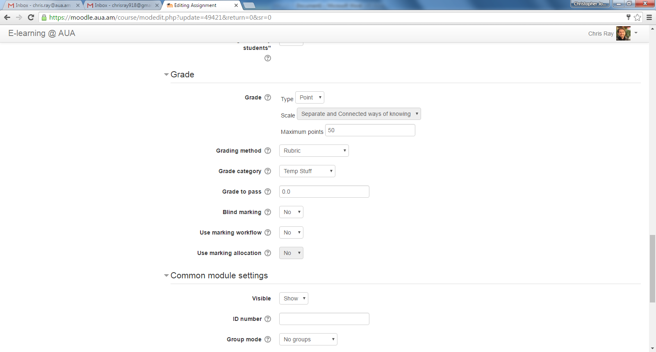
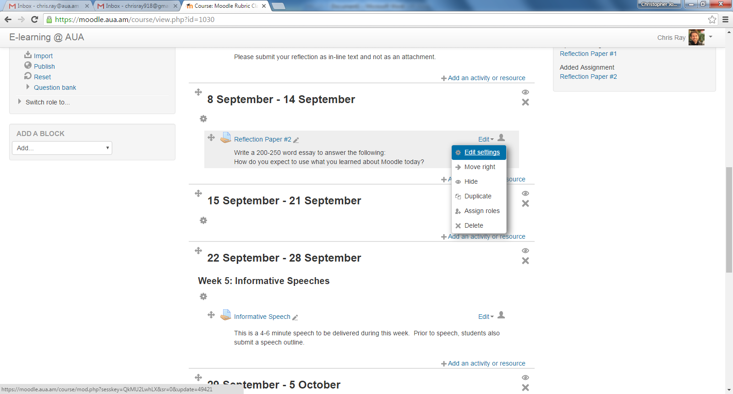

- Suggestion: Every time that you “edit settings” on an assignment, “expand all” sections (top, right).
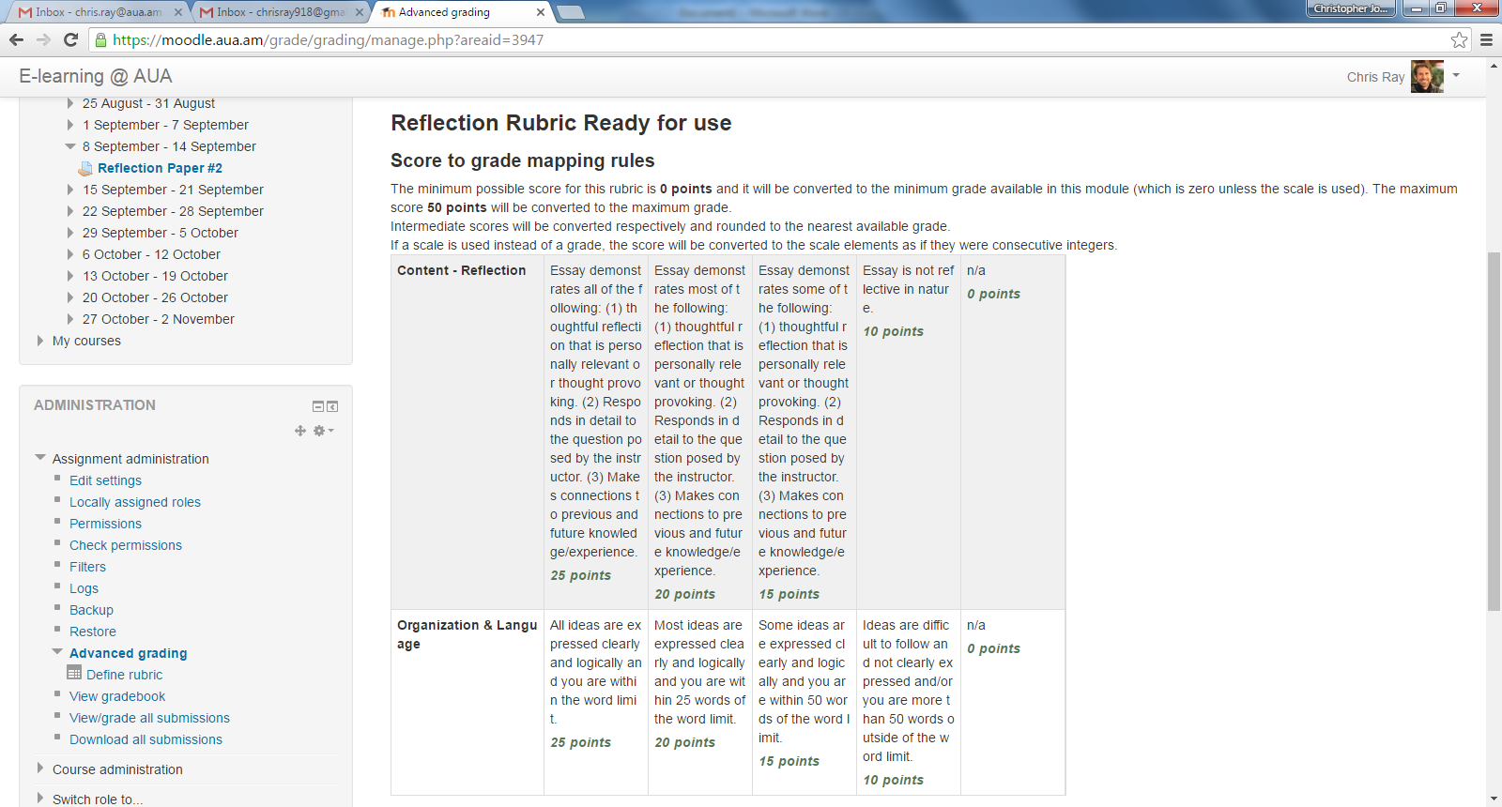
Notes on your Gradebook
- Use categories for different types of grades
- Category Subtotals – change “Aggregation” from “Mean of grades” to “Natural”.

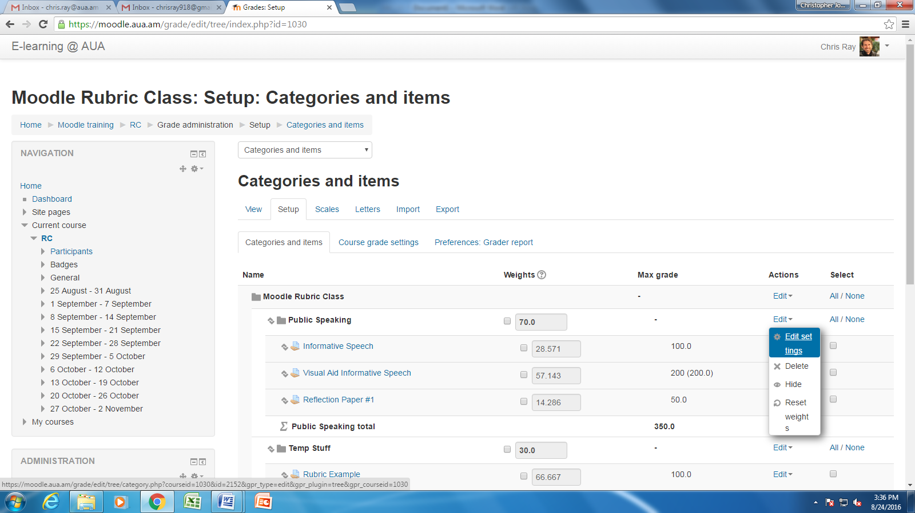

Practice Assignment: Term Paper

Add activity: “Your Name Paper”

Content – Thesis and structure | Excellent  30 points | Average  25 points | Below Average  20 points | Well-below Average  0 points
Content – Flow of ideas | Excellent  30 points | Average  25 points | Below Average  20 points | Well-below Average  0 points
Grammar | Excellent  30 points | Average  25 points | Below Average  20 points | Well-below Average  0 points
Length | Within Limits  10 points | Slightly Above/Below Limits  8 points | Below/Above Limits by more than 1 page  6 points | Not even close  0 points

